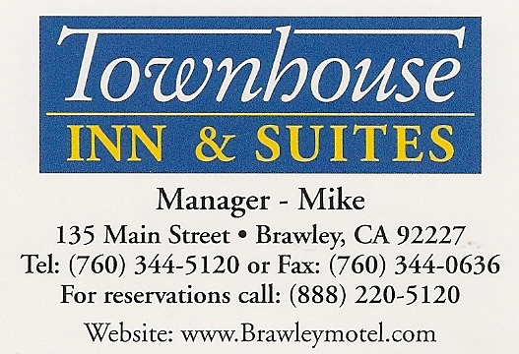
Email:-brawleymotel@yahoo.com or mehul.p@sbcglobal.net
Townhouse lodge Credit Card Authorization Form

I ____________________________ of _____________________ Company hereby authorize the following listed of Employees to Charge on credit card
Room and Tax Phone Yes or No
Name Employees:______________________________________________
_____________________________________________________________
_____________________________________________________________
Check date Check out dates No Nights
Number of Room Type of Room

Rate per Night (without Tax)

Type of card _______________________
Card Number:_______________________
Exp Date ____________
3Or 4 digits code _______
Card billing address:_____________________________________________
_____________________________________________________________Name on card ________________________________________________
Name of authorization Parson:____________________________________
Name of contact person_________________________________________
Company Name:____________________________________________
Company address_____________________________________________
____________________________________________________________
Phone Number _______________ Extension___________________
Fax Number___________________
Person Made Reservation:___________________________________
E Mail Address:-
Date of Reservation:_______________________
Signature _____________________
Need copy of credit card both side and copy of drive license?
Cancel Reservation 1 day to arrival date to avoid penalty of room charge. Any Damage in room Result in charge
Check in time 2 pm check out time 11am No pet
Swimming pool, Continental Breakfast. Wireless Highspeed Internet Coin laundry barbeque grill
In room Microwave, Refrigerator ,Coffee Maker ,Toaster , Hairdryer , Iron ironing Board
Air Conditioning, Cable TV-VCR

